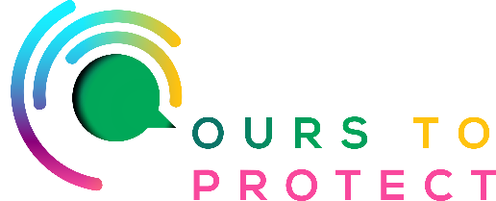
This week on Radio Nova we’re looking at better ways to recycle our waste.

From the pollution produced by landfills to the devastating effects of plastic in our oceans, we urgently need to stem the flow of rubbish pouring into our environment. Here's a reminder of why recycling is such a good thing – for you and the planet.

1. Conserving natural resources
The world's natural resources are finite, and some are in very short supply.
Recycling paper and wood saves trees and forests.
Recycling plastic means creating less new plastic, which is definitely a good thing.
Recycling metals means there's less need for risky, expensive and damaging mining and extraction of new metal ores.
Recycling glass reduces the need to use new raw materials like sand.

2. Protecting ecosystems and wildlife
Recycling reduces the need to grow, harvest or extract new raw materials from the Earth.
That in turn lessens the harmful disruption and damage being done to the natural world.

3. Reducing demand for raw materials
The world's increasing demand for new stuff has led to more of the poorest and most vulnerable people (for example, those living around forests or river systems) being displaced from their homes.

4. Saving energy
Making products from recycled materials requires less energy than making them from new raw materials.

5. Cutting climate-changing carbon emissions
Because recycling means you need to use less energy on sourcing and processing new raw materials, it produces lower carbon emissions.

6. Cheaper than waste collection and disposal
it is 6 times cheaper to dispose of recycled waste than general refuse. So, the more you recycle, and the less you put in the bin, the more money is saved, which should be good for everyone.

If in doubt, remember those three Rs: Reduce, Reuse, Recycle

Links for more information:

www.citizensinformation.ie/en/environment/waste-and-recycling/recycling-domestic-waste/
o

