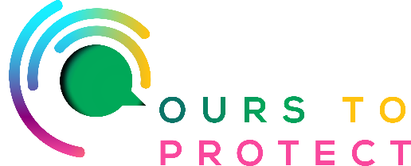

This week on Radio Nova we’re looking at the online resource hub the Earthy Marketplace.

The Earthy Marketplace aims to foster a supportive environment where people from all walks of life can come to make conscious purchasing decisions that have a positive impact, and gain access to information and resources that help connect communities.

It is made up primarily of 4 elements:

EARTHY EATS

Discover delicious plant-based food places to eat nearby. All kinds of food places catering 100% vegan or offering vegan-friendly options as part of their regular menu. Also featuring businesses where you can purchase vegan food items and confectionery!

FARM FINDER

Find and support, Independent Organic Growers who are farming with nature to provide the freshest, tastiest fruit and vegetables!

SHOP SUSTAINABLE!

Browse an eclectic range of small sustainable businesses from all over Ireland and shop sustainably!

EARTHY FRIENDS

Meet with Earthy Friends! A whole host of conscious/environmental NGOs, charities, and not-for-profit groups and organisations from all over Ireland! The Earthy Marketplace raises awareness of the important work being done by great people who give so much in an earnest fight to help create a better world for all.

Links for more information:

www.theearthymarketplace.com
o

